Installing DMFT

1. Open CMD as administrator, type: **Bcdedit.exe -set TESTSIGNING ON** (In order to set the machine as test mode to enable installing unsealed FWs), then apply restart.
2. Refer to the following location and select the required WW version: \\ger\ec\proj\ha\perc\Hardware_Releases
3. Refer to the required WW and look for WOS folder, for example: \\ger\ec\proj\ha\perc\Hardware_Releases\2018_WW05\ED\WOS
4. Refer to <https://www.python.org/ftp/python/2.7.13/python-2.7.13.amd64.msi> and install it (**python 64 bit**)
5. Copy the WOS folder, then refer to: RS400Camera.inf
6. Right click and press install.
7. Refer to cmd then type: **pip install pythonnet**
8. Refer to Mevice Manager->Imaging devices and make sure that intel cameras appear with related name like: 410, if not delete the camera and restart the PC.
9. Refer to environment variables and change the value of the key: **REALSENSE_DRIVER** to: **MEDIACAPTURE**
10. 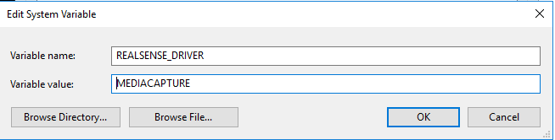
11. Install **vc_redist.exe** x86/x64 

# Device Manager

Connect the camera to the NUC, then refer to Device Manager:

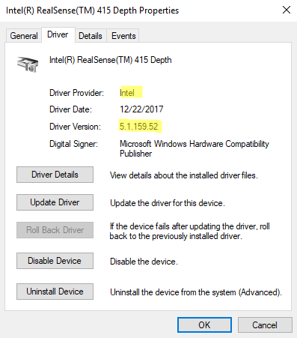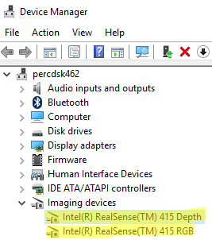

Refer to registry editor:

**Computer\HKEY_LOCAL_MACHINE\SYSTEM\CurrentControlSet\Services\RealSenseCameraDFU**

Then change the value of the key: **DFUAutoMode** to: **Disabled**

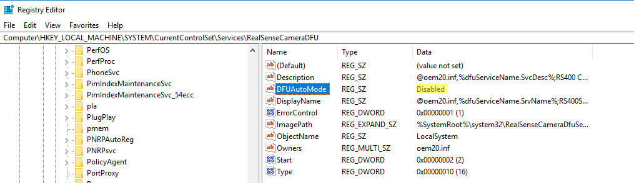

# Burning new FW version

1. Select:

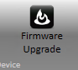

1. 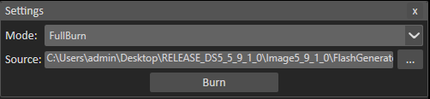110

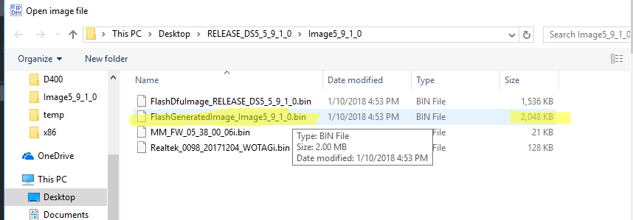

1. Disable the DFU (downgrade option in the registry editor):
   1. Copy the files **DisbaleDFU.bat** and **disable_dfu.xml**  to C:\ drive.
   2. Run the attached **DisbaleDFU.bat** file.
   3. Open **Tasks Scheduler->** **Tasks Scheduler->Import Task->disable_dfu.xml**
   4. Press **Run**.



4. How to delete the DMFT driver?

a. refer to **Device Manager**->**Imaging Devices**

b. Select each Intel RealSense Camera

c. Press right click mouse button

d. Uninstall Device

e. Check the check box**: [ ] Delete the driver software for this device**

f. Press Uninstall